**Term Paper**

**Section 1: What is already known on this topic**

In less than three single-sentence bullet points, please summarize the state of scientific knowledge on this topic. Emphasize on “why” this study needed to be done.

**Answer**

1. The human gut microbiome is important in human health, but 16s rRNA sequence metagenomic cannot determine quantitative functional.
2. The fecal metabolome can be a functional readout of microbial activity
3. The fecal metabolome can be phenotype which is intermediate between host and gut microbe
4. The fecal metabolic profile can link among microbiome, host phenotypes, and heritable complex traits.

**Section 2: What this study adds**

In one or two single sentence bullet points, give a simple answer to the questions “What do we now know as a result of this study that we did not know before?” “Are there any implications for practice, research, policy, or public health? “Be brief, succinct, specific, and accurate.

**Answer**

1. metagenomic sequencing can be use as quantitative and functional annotation for species and microbial pathways. Moreover, Fecal metabolomics can be the intermediate complementary to lead more completely profile.
2. relationships among fecal metabolites and host and microbial genetics should be further study on the influence of environmental factors, and should be study in particularly nutrition to confirm the association model
3. During the study of association, this article found the strong association between the fecal metabolome and central obesity. It can be confirming hypotheses on the microbial amino acid metabolism in obesity

**Section 3: How the data were analyzed**

Pick 3 figures and describe the followings

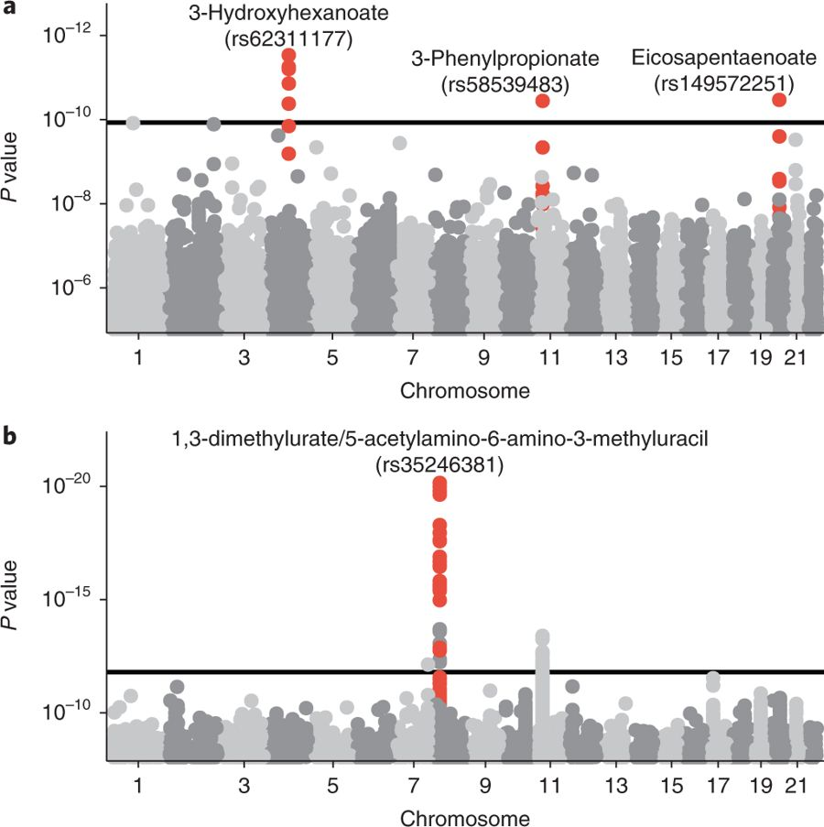

1. What is question that this figure tried to answer?

**Answer**

How many of loci the loci in human genetic or the whole set of human chromosomes which associations with fecal metabolites in the discovery sample. And the loci which passed though the horizontal line indicates the Bonferroni cutoff of 1.2 × 10−10? And what the fecal metabolites which associate to that loci?

1. What data have been generated to answer the question?

**Answer**

There are three loci passed the Bonferroni threshold, including 3-Hydroxyhexanoate at loci on chromosome 4, 3-Phenylpropionate at loci on chromosome 11 and Eicosapentaenote at loci on chromosome 20.

1. What analysis have been done to get to the conclusion?

**Answer**

This article conducted a genome-wide association study for the 428 metabolites with a heritable component and identified three metabolites (the amino acid 3 phenylpropionate and two lipids, eicosapentaenoate and 3-hydroxyhexanoate) that were significantly associated with genetic loci after correction for multiple testing



1. What is question that this figure tried to answer?

**Answer**

How many of loci in human genetic or the whole set of human chromosomes which associations with fecal metabolites in the discovery sample that passed though the horizontal line indicates the Bonferroni cutoff of P < 1.6 × 10−12? And what the fecal metabolites which associate to that loci?

1. What data have been generated to answer the question?

**Answer**

There are two loci passed the threshold; including, the loci in chromosome 8 which associate with 1,3-dimethylurate/5-acetylamino-6-amino-3-methyluracil (*P* = 6.2 × 10−21) and other loci in chromosome 11 passed Bonferroni cutoff of P < 1.6 × 10−12 filtering. Therefore, loci in chromosome 8 gain the *P* gain more than 8.9 × 105 thus it can be considered as the strongest association of each individual metabolite among all loci.

1. What analysis have been done to get to the conclusion?

**Answer**

This article tests genetic associations with metabolite ratios, which suits for chemical reactions than single metabolites. And replicated the results of our genome-wide association study in an independent sample of 230 individuals

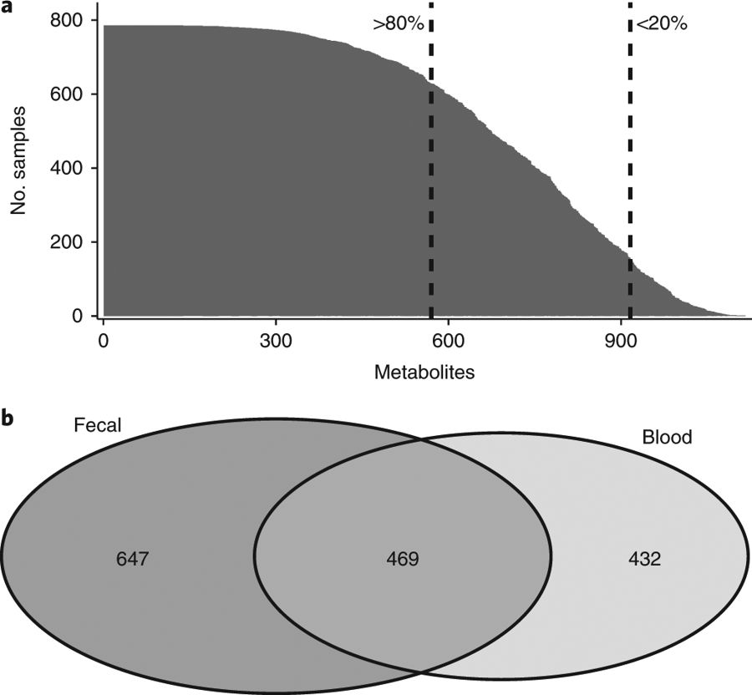

1. What is question that this figure tried to answer?

**Answer**

What are the number of measured and identified fecal metabolites from each participants’ fecal samples untargeted metabolomics profile?

1. What data have been generated to answer the question?

**Answer**

There are approximately 1,116 metabolites were measured whereas 866 are known chemical identity were detected which can be divide into three groups.

First group is 80% of the samples which is 570 common compounds. Next is detected in at least 20% but less than 80% of all samples whereas 345 compound analyzed as dichotomous traits. And the last group is less than 20% of the samples were discarded from further analysis.

1. What analysis have been done to get to the conclusion?

**Answer**

This article used Untargeted metabolomics profiling of the participants’ fecal samples was conducted through mass spectrometry performed by Metabolon, Inc.